Performance of length-based data-limited methods in a multi-fleet context: application to small tunas, mackerels and bonitos in the Atlantic Ocean.

Maite Pons 1, Laurence Kell 2, Merrill B. Rudd 1, Jason M. Cope 1, 3 and Flávia Lucena Frédou 4

1 School of Aquatic and Fishery Sciences, University of Washington, Box 355020, Seattle, Washington 98195-5020, USA

2 Centre for Environmental Policy, Imperial College London, London SW7 1NE, UK.

3 National Oceanic and Atmospheric Administration Fisheries, Northwest Fisheries Science Center, Fishery Resource Analysis and Monitoring Division, 2725 Montlake Boulevard East, Seattle, Washington 98112-2097, USA.

4

***Abstract***

Generally, large scombrids (data-rich commercial tuna species) are regularly assessed and managed. However, most of the small scombrids (data-poor mackerels and bonitos) lack accurate catch data to implement traditional stock assessments, although are economical important in many artesianal fisheries. In this study, we analyzed different approaches using length composition data from multiple fleets with different selectivity to assess small scombrids in the Atlantic Ocean. Using a simulated population, we compared two length-based methods, length-based spawning potential ratio (LBSPR) and length-based integrated mixed effects (LIME), under different length data grouping scenarios. We found that, using length data from the fleet targeting the broadest range of sizes resulted in the lowest bias of all options tested. Based on these results, we estimated for the first time a quantitative proxy of current stock status for 10 small scombrid stocks in the Atlantic Ocean using biological and length data. We found that a few small scombrid stocks have high chances of undergoing overfishing, such as little tunny in the southeast Atlantic and wahoo in the Northwest. This is a starting point in the estimation of stock status for these species, but should not replace other more data-intensive assessment techniques as new data become available.

## Introduction

For the “principal market tunas”, like Southern (*Thunnus maccoyii*), Pacific (*T. orientalis*) and Atlantic bluefin (*T. thynnus*), bigeye (*T. obesus*), yellowfin (*T. albacares*), albacore (*T. alalunga*) and skipjack (*Katsuwonus pelamis*), stock assessments are performed regularly and a variety of management procedures are in place to protect these stocks from overfishing (Pons *et al.* 2017). However, there are also other scombrid species, commonly referred to as small tunas, mackerels, Spanish mackerels and bonitos (from now on small scombrids), that account for a notable proportion of the total tuna and tuna-like species catch, that are mostly unassessed and unmanaged (Juan-Jordá *et al.*, 2015; Pons *et al.*, 2018). Small scombrids are generally coastal and associated with continental shelves and islands (Collette and Nauen, 1983). Although their economic value is lower than the principal market tunas (Collette *et al.*, 2011), they sustain important regional commercial fisheries in many coastal communities throughout their distributions (Majkowski 2007). Juan-Jorda *et al.* (2011) showed that within all of the Scombridae family, the steepest declines in biomass are exhibited not only for the largest, longest lived, highest valuable tunas, but also for a few smaller, short-lived mackerels. Also, some small Scombridae stocks in the Atlantic Ocean were recently assigned as “moderate to high risk”, even if they have not been formally assessed in recent years (Lucena-Frédou *et al.*, 2017a).

Total catch is one of the main data sources required for most of the classical stock assessment methods, particularly when deriving absolute estimates of spawning or total biomass. Stock assessment methods used for principal market tunas use catch data, but obtaining accurate landings and discards for small scombrids is generally challenging (Pitcher *et al.*, 2002). Small scombrids are targeted by multiple fleets, particularly medium- and small-scale fisheries, and caught as bycatch in many industrial fisheries targeting commercial tuna species. The catch data available usually consist of incomplete catch time series from tuna Regional Fisheries Management Organizations (tRFMO) statistics, and catch time series that might be highly aggregated by species from the Food and Agriculture Organization (FAO) database (FAO, 2016). While quantifying total catch is difficult, there is a wide-ranging toolbox of qualitative and quantitative assessment approaches for data-limited fisheries that use life history characteristics and length data to infer the exploitation status of the stocks (Chrysafi and Kuparinen, 2016; Dowling *et al.*, 2016). In 2017, Lucena-Frédou *et al.* (2017b) performed a qualitative risk assessment for small scombrids in the Atlantic Ocean. They identified five of 13 species as priority for evaluation and implementation of future management actions: the low productivity and susceptible *Euthynnus alletteratus* (little tunny), *Acanthocybium solandri* (wahoo) and *Scomberomorus cavalla* (king mackerel); and the highly targeted *Sarda sarda* (bonito) and *Auxis thazard* (frigate tuna) (ICCAT 2017a). This 2017 study served to identify priority species, but does not estimate population processes, productivity, or stock status that would be required for more specific management advice.

The International Commission for the Conservation of Atlantic Tunas (ICCAT) suggested that length composition of the catch could be used to quantitatively assess these species’ status and inform management advice. In fisheries without total catch data or information on absolute abundance, stock assessments typically use the spawning potential ratio (SPR) as an alternative reference point to maximum sustainable yield (MSY). SPR is defined as the proportion of the unfished reproductive potential per individual under a given level of fishing pressure (Goodyear 1993) and it has been recommended for data-limited assessment because it requires only biological information and an estimate of fishing mortality (Brooks *et al.*, 2010).

This study explores two data-limited stock assessment that require length composition data and life history information, both of which datasets are available for small scombrids (Juan-Jordá *et al.*, 2016; ICCAT, 2018). Length-based spawning potential ratio (LBSPR, Hordyk *et al.* 2015a) uses the Beverton-Holt life history invariants in an equilibrium-based population model using the shape of the length composition data compared with the expected unfished length structure to estimate *F/M* and derive SPR. The length-based integrated mixed effects model (LIME, Rudd and Thorson 2017) requires assumptions about *M*, growth, and maturity parameters in an age-structured model fit to length composition data, relaxing equilibrium conditions of previous methods by treating recruitment as a random effect over time and estimating annual *F* as fixed effects (Rudd and Thorson, 2018).

Data-limited, length-based stock assessment methods assume selectivity is asymptotic by default (Hordyk *et al.*, 2015; Rudd and Thorson, 2018). If large fish are absent from the catch it is assumed they do not exist in the population (as opposed to being less vulnerable to the fishing gear). This assumption is usually violated in highly size-selective fisheries (i.e. gillnets) and it could be problematic in multi-fleet fisheries where stocks are caught in different proportions by multiple gears with different selectivity patterns. As an example, the majority of the catch of the North Atlantic Albacore stock comes from pole and line fisheries which have a dome-shaped selectivity, catching mainly juvenile albacores. In addition, a smaller proportion of the catch comes from longline fisheries targeting larger individuals, but with different selectivity patterns depending on the fishery (ICCAT, 2014). These different selectivity patterns, catch, and indices of abundance are included in complex assessment models that allow for multiple fleet interactions in the formal assessment performed regularly by ICCAT. When fitting only to length composition of a proportion of the catch, assumptions regarding fishery dynamics, including the shape of the selectivity curve, needs to be carefully analyzed.

The overarching objective of this study was to develop best practices for combining length data across multiple fleets for length-based assessments of small scombrids in the Atlantic Ocean. To address this objective, we used simulation testing to evaluate the performance of LBSPR and LIME combining length composition data of the catch from multiple fleets with different selectivity patterns. Using conclusions from the simulation, we applied both length-based approaches to estimate stock status for the priority small scombrid species determined by ICCAT (ICCAT, 2018).

## Methods

### First we compared the performance of two length based methods using a simulation study based on North Atlantic albacore, then based on the insight about the robustness of the methods we estimated stock status for the small tuna stocks.

### Simulation study

We chose the North Atlantic albacore stock on which to develop an Operating Model (OM) to simulate resource dynamics in simulation trials in order to evaluate the performance of the different assessment methods. ICCAT, in the 2017 Report of the small tunas species group intersessional meeting (ICCAT 2017b), suggested the North Atlantic albacore stock as a good example of a multi-fleet fishery to use for simulation purposes, where the selectivity patterns are known for 12 different fleets (ICCAT 2014a). This stock is targeted by pole and line, troll, longline and other surface gears in the Atlantic Ocean.

In the next sections, we describe the data and specifications used in the operating model (OM), the estimation models (EM), namely LBSPR and LIME, and how we measured their performance under different scenarios.

### Operating models

*Input data* – We extracted the catch time series (Supplementary Figure S1), selectivity patterns from 12 different fleets (Supplementary Figure S2), and the biological parameters (Table 1) from the formal assessment performed by ICCAT in 2013 for North Atlantic Albacore (ICCAT 2014a) to use for the OM. For simplicity and based on similarity of selectivity patterns (Supplementary Figure S2), we combined some fleets: (*A*) fleets 1 and 2 (bait boat and troll fisheries) which target small individuals and have a dome-shaped selectivity curve; (*B*) fleets 4 and 12 which are other surface gears targeting a broader range of sizes; and (*C*) fleets 10 and 11 which are longline fisheries targeting mainly adults with an asymptotic selectivity curve (Supplementary Figure S2). During the last 15 years only 4 of the fisheries were still operating (the three fleet combinations mentioned earlier plus fleet 7 which is a longline fleet that capture less than 1% of the total catch). Eighty-eight percent of the total catch corresponds to the fleets bait boat and troll fisheries (*A*), 6% longline (*C*)and 7% other surface gears with same selectivity (*B*) (Figure 1).

*Model specifications* - We simulated an age structured population using Stock Synthesis (SS) Version 3.30.10 (Methot and Wetzel, 2013; Methot *et al.*, 2018). We specified a final depletion fitting to an artificial abundance survey index equal to 1 at the beginning of the time series (1930) and 0.4 B0 in the last year (2011). All parameters were fixed, except the average recruitment in the unfished state (*R0*). We simulated 2 populations, one with and one without recruitment deviations. We assumed a Beverton-Holt spawner-recruit function (Beverton and Holt, 1957; Methot and Wetzel, 2013).

Fishing intensity in SS is estimated to match the observed North Atlantic Albacore catch. SS assumes that the absolute level of catch is known, using the catch time series to calculate the level of fishing intensity needed to obtain that level of catch conditioned on the model’s current estimate of age-specific population abundance and age-specific selectivity (Methot and Wetzel, 2013). SS calculates the SPR as the equilibrium level of spawning biomass-per-recruit that would occur with the current year’s level of fishing intensity relative to the unfished level of spawning biomass-per-recruit (Goodyear, 1993).

After runningSS to generate the OM, we extracted the expected catch at age by year and fleet from the SS report. We converted this catch at age in biomass into catch at age in numbers using the mean weight at age. We used the age-length transition matrix output from SS to assign a distribution of length at each age (Supplementary Table S1). Summing across each length bin by gear gave us the length distribution of the catch. We used a 2 cm length bin as in the formal ICCAT assessment (ICCAT 2014). In order to analyze different length sampling scenarios, we sampled 100 individuals from the catch by year and fleet with a multinomial distribution using the probability of being harvested at each length bin for each year. We repeated this process of simulating a population and generating data for 100 replicates for each scenario.

*Scenarios –* A common question that arises with length data from multi-fleet fisheries with different selectivity patterns is which fleets to use and how to combine data from them when applying length-based data-limited methods that only estimate selectivity and fishing mortality for one fishing gear. We explored the performance of each estimation method under different approaches combining length data into one common “fleet” (combined length frequencies coming from all of the fleets when more than one fleet was used) or selecting only one fleet. In all scenarios the selectivity for this one fleet was estimated and starting values were the same for each model run. We explore 5 possible scenarios:

Scenario 1 – Length composition sampled proportional to the catch of each fleet (Figure 1). This means that fish measured from the fleet with the highest catch would be more represented in the length composition data than other fleets.

Scenario 2 – Length composition sampled with equal weight from each fleet. This means that the same number of individuals were measured from each fleet and combined in one length-sample. All fleets are equally represented in the length composition data.

Scenario 3 – Only use length data from the fleet that targets small individuals (Fleet *A*). Fleet *A* has a dome-shape selectivity where the true S50 is 57 cm (~ age 1.5) and S95 is 61 cm (~ age 2). This fishery catches mainly juveniles and it is the main fishery for North Atlantic Albacore in terms of catch (Figure 1).

Scenario 4 – Only use length data from the fleet that targets a broad range of lengths (Fleet B). Fleet B has an asymptotic selectivity harvesting both juveniles and adults, with a true S50 of 78 cm (~ age 3.5) and S95 of 90 cm (~ age 5, Figure 4.B). In terms of catch, this fleet resents a small proportion of the total (Figure 1).

Scenario 5 – Only use length data from the fleets that target adults (Fleet C). Fleet C also catches a small fraction of the total catch (Figure 1) but it is a longline fishery that targets mainly adults with a true *S50* of 100 cm (~ age 7) and a *S95* of 108 cm (~ age 9).

### Estimation models

In LBSPR, SPR in an exploited population is a function of the ratio of fishing mortality to natural mortality (*F/M*), and the two life history ratios *M/k* and *Lm/L∞*; *k* is the von Bertalanffy growth coefficient, *Lm* is the size of maturity and *L∞* is asymptotic size (Hordyk *et al.*, 2015). The inputs to the LBSPR are: *M/k*, *L∞*, the variability of length-at-age (*CVL∞*), which was set as 10% in the OMs; and size of maturity specified in terms of *L50*and *L95*, the size at which 50% and 95% of a population matures (Table 1). Given the assumed values for the *M/k* and *L∞* parameters, and length composition data from an exploited stock, the LBSPR model uses maximum likelihood methods to estimate the selectivity ogive, which is assumed to be a logistic curve defined by the selectivity-at-length parameters *S50* and *S95*, and the relative fishing mortality (*F/M*), which are then used to calculate the SPR (Hordyk *et al.*, 2015). LBSPR estimates a selectivity curve for each time step. Estimates of SPR are primarily determined by the length of the fish in a sample, relative to the maturity and *L∞*. If a reasonable proportion of fish in a sample attain lengths approaching *L∞*, estimates of *F/M* will be relatively low leading to a high estimate of SPR. LBSPR is an equilibrium-based method with some underlying assumptions including: (i) asymptotic selectivity, (ii) growth adequately described by the von Bertalanffy equation, (iii) a single growth curve can be used to describe both sexes which have equal catchability, (iv) length at-age is normally distributed, (v) rates of natural mortality are constant across adult age classes, (vi) growth rates remain constant across the cohorts within a stock, and (vii) and constant recruitment (Hordyk *et al.*, 2015). In this study we used LBSPR package version 0.1.2 in R (Hordyk, 2017).

LIME uses length data and biological information to estimate annual *F*, the selectivity-at-length parameters *S50* and *S95*, recruitment standard deviation, and the Dirichlet-multinomial parameter related to effective sample size of the length data. These parameters are used in an underlying age-structured model to derive population parameters such as SPR and relative spawning biomass. LIME has the same assumptions as LBSPR, but LIME does not assume equilibrium conditions; LIME extends length-based methods by deriving time-varying recruitment deviations (Rudd and Thorson, 2018). LIME uses automatic differentiation and Laplace approximations (TMB) (Kristensen *et al.*, n.d.) to calculate the marginal likelihood for the random effect on recruitment. All other data requirements are the same as LBSPR but LIME estimates one selectivity curve for the entire time series of length data, while LBSPR estimates one selectivity for each year since LBSPR treats multiple years of length data independently (Hordyk *et al.*, 2015). LIME can also accommodate catch and/or abundance data if available (Rudd and Thorson, 2018), although this feature was not used in this study. We used the LIME package version 1.0.5 (Rudd, 2018).

### Performance measures

The performance of the EMs under different scenarios were compared with the simulated “truth” from the OM using relative error (RE) calculated as (*estimated-true)*/*true*, where *estimated* comes from the EM and *true* from the OM. This is a measure of uncertainty, in both bias and precision, of the EM under each scenario, and it is commonly used as a standardized metric of model performance. We used SPR as the performance measure for all scenarios estimated by both LIME and LBSPR. We presented the relative error of the last year of the time series of SPR in all cases for the 100 simulation replicates for each scenario.

### Small scombrids in the Atlantic Ocean.

Little tunny, bonito, wahoo, king mackerel and frigate tuna have been identified as priority to be evaluated by ICCAT in 2017 (ICCAT, 2017). In the present study, the only species that we did not evaluate was king mackerel. In the Southwest Atlantic there is no good information on length data to evaluate this stock and in the Northwest Atlantic it is regularly assessed by the US as two independent stocks: one in the Gulf of Mexico and the other off the Southeast coast of the US (SEDAR, 2014a, 2014b). According to these reports, neither stock of king mackerel in the Northwest Atlantic are currently overfished nor undergoing overfishing.

None of the other four species of small scombrids have studies defining stocks boundaries in the Atlantic Ocean. So, for management purposes, ICCAT uses five sampling or statistical areas for small scombrids: Northwest Atlantic, Southwest Atlantic, Northeast Atlantic, Southeast Atlantic and Mediterranean Sea (Supplementary Figure S3). Hence, we decided to use these areas as a proxy of stock boundaries to assess these putative “stocks”.

The ICCAT database (<http://iccat.es/en/accesingdb.htm>) has length data composition from 1975 to 2016 for the four priority species assessed in this study. The length composition data available for each stock comes from different regions and different gear types. Since our main goal is to estimate current stock status, we used only data from 2010 to the present where there is a better representation of the length composition of the catch by year and gear (Supplementary Figure S4). We used the length data reported in 1 and 2 cm bins and we pooled them into 2 cm length bins for the analysis. The number of fish measured by year for the priority species varies between 17,429 individuals measured in 2016 to 98,173 in 2014, all species combined (Supplementary Figure S4). We presented the stock status for the year 2014 where there are more length data and they are consistent among species and representative of different gears.

For some stocks the length data available was limited, so samples numbering fewer than 100 fish per year and gear combination from 2010 to 2016 (Supplementary Figure S4). Some stocks, such as wahoo in the South West, were excluded from the analysis because they are targeted by multiple fleets, but length data are available only for one gear (gillnets) and would bias the results. This filtering process reduced the number of stocks with enough information to run the length-based models. We did not run these models for bonito in the South East, Northwest and Southwest, little tunny in the Southwest, wahoo in the Mediterranean, Southeast and Southwest (stock not present in the Mediterranean), and frigate tuna in the Mediterranean, Southwest and Southeast resulting in 10 stocks with representative information of length composition data of catch by gear (Supplementary Figure S5).

Both LBSPR and LIME require life history information on growth, maturity and length-weight relationships as input parameters. These methods are very sensitive to these parameters (Hordyk *et al.*, 2015; Rudd and Thorson, 2018). In 2018, the ICCAT small tunas working group met and a set of life history parameters were agreed among scientist from each region in the Atlantic Ocean for each stock to run data-limited methods (ICCAT 2018, Supplementary Table S2). There are a lot of gaps in the life history information available for these species. In cases where there were missing information for the life history parameters, we borrowed information from the nearest stock of that species (i.e. when missing information existed for the South East Atlantic, we borrowed the information from the Northeast Atlantic) to run the length-based models.

Table 2 shows the final parameters used for each stock to run LBSPR and LIME. Natural mortality (*M*) was calculated using different empirical life-history based methods (Cope 2017, see <http://barefootecologist.com.au/shiny_m>). We used 9 methods which use growth life history parameters (*L∞, k, t0* and maximum age) (Alverson and Carney, 1975; Chen and Watanabe, 1989; Jensen, 1996, 1997; Then *et al.*, 2015). Table 2 shows the median and 1st and 3rd quantile of the distribution of *M* estimated for each stock. LBSPR and LIME were run with these three *M* values to test their sensitivity to these parameter estimations*.*

### Reference points for small scombrids

We used SPR as a biological reference point. In general, it is used as a proxy of MSY when information on the scale population size is not available. A harvest strategy that targets a fishing mortality rate that is expected to results in 40% of the unfished spawning output (SPR40%), is considered a reasonable proxy even for stocks with very low resiliency (Clark, 2002). Moreover, 30% of SPR is sometimes considered a threshold beyond which overfishing would be occurring (Clark, 2002; Nadon *et al.*, 2015; Rudd and Thorson, 2018). In addition, we presented the estimated ratio *F/M* for each stock.

## Results

### Simulation testing: length data in multi-fleet fisheries

Based on the observed catch data for North Atlantic Albacore used in the OM, the true SPR value in the terminal year was 0.55 for the OM without recruitment deviations, and for the OM that includes random recruitment deviations the median was 0.66 with a range between 0.50 and 0.74 (Supplementary Figure S6). LBSPR was least biased in when using length data from the fleet with asymptotic selectivity catching a broad range of lengths from juveniles to adults (Scenario 4; Figure 2). LIME was least biased with length data from the fleet that targets only adults when considering recruitment variability (Scenario 5; Figure 2). Both models estimated SPR higher than the truth when using the length composition data weighted by catch (Scenario 1) and length data from the fleet with dome-shape selectivity (Scenario 3). SPR was highly overestimated when considering the same weight for each fleet (Scenario 2). LBSPR was highly biased when using length composition from the fleets targeting only adults (Scenario 5; Figure 2).

In Scenario 1 length composition data was weighted by the catch, so in this case more weight was given to the fleet with dome-shape selectivity. In this scenario both LBSPR and LIME underestimated SPR on average in both recruitment scenarios (Figure 2). Under an asymptotic selectivity assumption, if large individuals are absent from the catch, both assessment methods estimate *F* to be higher than the truth and then SPR lower than the truth. LIME estimated SPR to be almost zero. Results from Scenario 3 were similar to Scenario 1 since both scenarios put higher weight on length compositions consisting of mainly juveniles or smaller individuals than the full span of vulnerable fish.

Under Scenario 2 sampling the same number of individuals by gear type, LBSPR and LIME estimated SPR higher than the truth, particularly when the OM did not consider recruitment variability. When considering recruitment variability, LBSPR was positively bias although LIME was less biased but less precise. Under these scenarios the proportion of large individuals in the catch was overrepresented leading to the EMs estimating higher SPR values than expected. The same overestimation of SPR occurred in Scenario 5 using the fleet that targets adults when no recruitment variability was included in the OM due to the proportions of large individuals in the catch.

LBSPR was less biased in Scenario 4 when considering only the fleet with an asymptotic selectivity that captures a broad range of sizes, while LIME was less biased under the scenarios with recruitment variability when considering the fleets with gears that selected mainly adults in Scenario 5 (Figure 2). We observed that in many cases LIME estimates higher selectivity parameter values, *S50* and *S95*, than LBSPR, meaning that the model expects larger individuals in the length composition of the catch than was observed and then estimates low SPR values. This is probably the reason why LIME performs better when using fleets that target large fish and why LIME SPR estimate are lower than LBSPR when using the same data.

### Assessments of small scombrids in the Atlantic Ocean.

Based on simulation testing, none of the Scenarios produced the best performance for both estimation models (LIME and LBSPR) simultaneously. LBSPR performed best in Scenario 4 which used the length data coming from the fleet with an asymptotic selectivity targeting a broad range of lengths. LIME however, performed better in Scenarios 5, where mainly adults were represented in the catch. So, based on these results, we decided to apply both LIME and LBSPR using the length composition data from small scombrids from the fleet that has a broader range of sizes including adults, but not restricted to the adult portion of the catch. The gears used then varied among Small tuna stocks.

The length composition data for each stock by gear, filtered by year-gear combinations with at least 100 length measurements, varies among areas likely based on differences between fleets operating in each region. Length composition data for little tunny is available for two gears in the Northwest Atlantic, but rod and reel has better representation by year and length range compared with traps (Supplementary Figure S5). In this case we used length data from rod and reel only to assess this stock. For little tunny in the Northeast Atlantic we selected the length data coming from traps since they cover a broader range of ages including adults, despite the fact that there are no data in 2011. For little tunny in the Mediterranean we used length data from longlines and for the Southeast Atlantic we used data from gillnets (Supplementary Figure S5). For wahoo in the Northeast we used the length composition from hand lines since is the only information available, and rod and reel for the Northwest. For bonito in the Mediterranean, we used length data coming from longlines just as we did for little tunny in the same area. Finally, for frigate tuna in the Northeast and in the Southeast we selected the length data coming from purse seine fisheries (Supplementary Figure S5).

For some small scombrids stocks, the SPR estimates were below the target of 40%, but the results varied between assumptions about *M* and the estimation method considered (Figure 3). LBSPR and LIME predicted different values of SPR, and sometimes the estimated values were far apart, such as for bonito in the Mediterranean and in the Northeast (e.g. 0.2 with LIME and 0.6 with LBSPR). LIME estimated a lower selectivity than LBSPR and then a higher *F* and lower SPR (Supplementary Figure S7. A). On the contrary, for bonito in the Northeast, LIME estimated a higher selectivity ogive and a lower *F* and higher SPR than LBSPR. LIME estimated that during 2014 there was a high recruitment and then the small individuals in the catch were attributed to the recruitment spike, as opposed to LBSPR which interpreted the small individuals as a high *F* (Supplementary Figure S7. B). As expected, when *M* was assumed to be lower than in the base case scenario (median *M*), the SPR estimations were lower (Figure 3).

Little tunny in the Southeast was below 40% in all cases except when LIME assumed a high *M*, leading to an SPR estimate of 0.7 (Figure 3). Assuming the median value of *M*, LBSPR predicted a very high *F* and SPR values below 20% for the entire time series. LIME also predicted low SPR values, around 30%, and a much lower *S50* than LBSPR (Supplementary Figure S8. A). The results of LBSPR and LIME were more similar for little tunny in the Northwest (Supplementary Figure S8. B), Mediterranean (Supplementary Figure S8. C) and Northeast Atlantic (Supplementary Figure S8. D), estimating that SPR for these stocks were above the 40% target reference point. For little tunny in the Mediterranean the ration between *F/M* is high (above 2) even though SPR is above 40%.

SPR estimates for both LBSPR and LIME for wahoo in the Northwest were below 40% (except in the high *M* scenario with LIME). LIME predicted very high *F/M* and SPR below 40% except when assuming a higher *M* for wahoo in the Northeast. In both the Northwest and Northeast, LIME predicted a higher *S50* and a lower SPR than LBSPR (Supplementary Figure S9. A and B). None of the frigate tuna stocks assessments estimated SPR below 40% except with LIME in the low *M* scenario where SPR was estimated at approximately 20% for the Northeast and Southeast stocks (Figure 3).

## Discussion

The present study analyzed different approaches using length-based data-limited assessments when length composition data come from fisheries with multiple gears with different selectivity patterns. An aim of this study was to evaluate how to use length composition data from multi-fleet fisheries to estimate stock status for small scombrids. Although the results observed here can be applied to other multi-fleet fisheries, the results show enough variation, so further simulation testing for data-poor multi-fleet fisheries with variable life history and exploitation patterns should be considered.

### Length data in multi-fleet fisheries

We showed how stock assessment results could be highly biased when using only one gear, not representative of the length of the exploited population, particularly when the assumptions of asymptotic selectivity are violated (e.g. albacore length data coming from bait boat and troll fisheries targeting juveniles with a dome-shape selectivity). In this case, high catches of smaller individuals resulted in an underrepresentation of the proportion of adults in the population, estimating a lower SPR value than the actual value. Even if the asymptotic selectivity assumption is met (i.e. albacore length data coming from longline fleets targeting adults), LBSPR and LIME overestimated SPR. Hordyk *et al.* (2015a) suggested that when there are multiple fleets targeting the same stock, the LBSPR model should be applied to the data from the fleet that targets the adult portion of the stock. However, we found that SPR estimates were biased for small scombrids in this case. In all the scenarios analyzed by Hordyk *et al.* (2015a) the *S50* was lower than the *L50*, but in our scenarios 5 and 6, the *S50* was higher than the *L50*, potentially explaining why they did not find this bias in their results. SPR estimates are primarily determined by the size of the fish in a sample relative to both size at maturity and *L∞*. In our Scenario 4, where the *S50* was lower than the *L50*, LBSPR was less biased.

Based on our results, we recommend that when there are multiple fleets with different selectivity patterns targeting one stock, length-based models should be applied to the length data coming from the fleet that targets the broadest range of sizes including adults, but not restricted only to the adult portion of the catch. SPR estimates improve when the catch length sample is representative of the length composition of the exploited population.

Rudd and Thorson (2017) tested the performance of LIME under LBSPR’s own OM (Hordyk *et al.* 2015a), with relative ages based on the *M/k* ratio. They found that LBSPR performs well across all life history types, but LIME under-estimated SPR for the medium- and longer-lived life history types, and over-estimated SPR for the short-lived life history type. However, in most of the non-equilibrium scenarios LIME performed better than LBSPR. We also found in most of the scenarios considered that LIME estimated a lower SPR than LBSPR for this medium lived tuna species. This suggests that LIME provides status determinations that are more conservative.

### Small scombrids stock status

LBSPR is run independently each year, resulting in separate annual estimates of SPR, selectivity parameters, and the ratio of fishing mortality to natural mortality (*F/M*). However, LIME includes length composition data available for multiple years in the same model to estimate a single selectivity curve for all years and fishing mortality and recruitment that can vary among years. Therefore, assumptions and model structure are different between LIME and LBSPR, so it is unsurprising that results differed.

We did not find a specific pattern in exploitation status among regions, meaning that any particular region showed more small scombrids stocks under overfishing than others regions (Figure 3). Although some combinations of stock assessment model and natural mortality rate resulted in differing estimates of stock status, the approaches agreed under the base scenario with median *M* that 2 stocks out of 10 are undergoing overfishing: little tunny in the Southeast and wahoo in the Northwest.

*Little tunny*: the length composition data for little tunny in the Northeast and Northwest Atlantic from purse seiners were very similar (Supplementary Figure S5), where the median length by year was just below 50 cm, but above the length at maturity (Table 2). Both assessment methods estimated SPR values above 40% indicating that these stocks are not undergoing overfishing. However, assessments for little tunny in the Southeast estimated SPR values below the target reference point of 40% in almost all scenarios considered, except when using LIME under a high *M* assumption. Most of the fish caught were below the length at maturity and this stock was estimated to be undergoing overfishing (Figure 3). These results are in agreement with a preliminary qualitative risk assessment analysis performed for small scombrids in the Atlantic Ocean considering two populations, North and South. The southern stock was found at high risk, while the northern populations were found at moderate risk (Lucena-Frédou *et al.* 2017). This species has an estimated maximum age between eight and ten years (Cayre and Diouf, 1980) and an estimate of *L∞* between 86 and 117 cm. Adults of this species above 60 cm in the Southeast are scarce in the length composition sample of the catch leading to low estimates of SPR. Along with Bonito and Frigate tuna, this species is one of the most captured among all small Scombrids (ICCAT, 2018).

*Bonito:* In the base case scenario bonito in the Northeast was estimated to have a SPR below target reference points with LBSPR, but not with LIME. The opposite was observed in the Mediterranean, where LIME estimated a lower SPR than LBSPR. Rudd and Thorson (2018) found that LIME generally estimated a higher SPR than the truth for short-lived fish in a yearly time step. A monthly time step could be considered in the future for this species to test for sensitivity to this assumption since the life span for this species is five years (Baibbat *et al.*, 2016).

Previous data-limited assessment methods were applied for bonito in the Northeast using Morocco landings data between 2012 and 2014. A Powell-Wetherall plot approach was used to explore changes in total mortality (*Z*) based on length samples and catch curve analysis using lengths converted to age and cohort slicing (Ahmed *et al.*, 2015). Assuming an *M* of 0.2 they found that fishing mortality is twice this value and they suggested that this stock might be fully exploited. The *M* values used in the present study were higher than 0.2 in all cases, so using such a low value for *M* could give similar results as in Ahmed *et al.* (2015). Lucena-Frédou *et al.* (2017) found that bonito for the North Atlantic was not vulnerable, but they also noted that the quality of the data used to evaluate this stocks was low. This species is the most captured among all small Scombrids (ICCAT, 2018), but the biological information as well as the length composition data available is highly fragmented and variable. Our results should be analyzed with caution, and as better data becomes available these stocks should be re-evaluated.

*Frigate tuna:* In almost all scenarios, the stocks were estimated to be above 40%. However, assessments for the Northeast stock always estimated lower SPR values than the one in the Southeast. Again, these results matched the preliminary risk assessment for small scombrids in the Atlantic Ocean, where stocks in the South are at lower risk than the ones in the North (Lucena-Frédou *et al.* 2017). However, both *F* and SPR estimates in the Southeast should be considered with caution since some of the results are in the low right quadrant at *F* close to 0 and SPR close to 1 with very high uncertainty. If *F* was estimated to be close to 0 it is likely that the life history information is inaccurate because we know the *F* is not 0 since the fishery is occurring. *L∞* might be too high, so both models would estimate no fishing if the observed lengths are very close to the asymptotic length. The growth parameters should be discussed again at the next small tuna group meeting to consider different values for life history for this stock.

*Wahoo:* This species in the North Atlantic was identified previously as low risk using a qualitative ecological risk assessment (Lucena-Frédou *et al.* 2017). However, both LIME and LBSPR estimated low SPR values for the Northwest stock, suggesting that this stock is undergoing overfishing. In the Northeast, only LIME in the base case and low *M* scenarios estimated that this stock is experiencing overfishing, but not LBSPR. In the South Atlantic wahoo has been categorized as high risk and no assessments are available for this stock. This species should be considered as a priority to assess by ICCAT.

### Future directions

Here, we estimate for the first time a proxy of the current stock status for 10 stocks of the small scombrids group of species in the Atlantic Ocean. This is a starting point in the estimation of stock status for these species, but the wide uncertainty in estimates combined with differences in results between LBSPR and LIME demonstrate that data-poor methods are not substitutes for more data-intensive assessment techniques. ICCAT should keep supporting the collection of improved life history information, length data from all gears, catch data, and fisheries for these 10 stocks and for all Small scombrids, as well as motivating for data that measure trends in abundance directly, in addition to improving biological information and catch data to perform a full assessment.

LBSPR and LIME, like all the age or length-based methods, are sensitive to misspecifications of the inputs of life information (Hordyk *et al.*, 2015; Rudd and Thorson, 2018). Sensitivity tests in these studies demonstrated the impact of the misspecification of biological parameters. Quantification of uncertainty is one of the next steps in the evaluation of these stocks, not only for *M*, but for other growth and maturity parameters, to provide support for local biological studies of these species. To account for the uncertainty in the biological parameters with the current information available in the Scombridae database (Juan-Jordá *et al.*, 2016), a Monte Carlo algorithm could be applied in future studies specifying prior distributions for life history parameters (Prince *et al.*, 2015).

### Conclusions

Small scombrid fisheries in the Atlantic Ocean are medium to small-scale, data-limited and generally unassessed, with a lack of management and enforcement, with exception of some regions in the Northwest Atlantic such in the US. Determining stock status is the first step to protect these stocks from overfishing and apply management measures to rebuild stocks that are currently undergoing overfishing. Since stock status for these species is highly uncertain, management strategy evaluation is needed to evaluate different harvest control rules accounting for data and model uncertainty. There are still many gaps in the biological information available for these stocks, so basic biological information such as growth, reproduction and natural mortality estimates are essential to improve our understanding of fishing impacts on these populations.

LIME has been used in data-limited stock assessments for small-scale fisheries in Costa Rica and Kenya (Rudd, 2017) and LBSPR in Palau (Prince *et al.*, 2015). Our study expands the application of these methods to stocks beyond tropical waters.

***Acknowledgments***

I would like to acknowledge our source of funding, The Walton Family Foundation and International Seafood Sustainability Foundation (ISSF). In addition, I would like to acknowledge the ICCAT Small Tunas working group for providing the information about life history traits for the small scombrids species.

## references

Ahmed, B. S., Abid, N., Palma, C., and Kell, L. 2015. A length based assessment for Atlantic Bonito (Sarda sarda). Collective Volume of Scientific Papers ICCAT, 72: 2208–2220.

Alverson, D. L., and Carney, M. J. 1975. A graphic review of the growth and decay of population cohorts. ICES Journal of Marine Science, 36: 133–143. Oxford University Press. https://academic.oup.com/icesjms/article-lookup/doi/10.1093/icesjms/36.2.133 (Accessed 15 June 2018).

Baibbat, S., Malouli, I., Abid, N., and Benazzouz, B. 2016. Study of the reproduction of atlantic bonito (Sarda sarda) in South Atlantic Ocean of Morocco. AACL Bioflux, 9: 954–964.

Beverton, R. J. H., and Holt, S. J. 1957. On the Dynamics of Exploited Fish Populations. Fishery Investigations (Great Britain, Ministry of Agriculture, Fisheries, and Food), London. 536 pp.

Brooks, E. N., Powers, J. E., and Cortés, E. 2010. Analytical reference points for age-structured models: Application to data-poor fisheries. ICES Journal of Marine Science, 67: 165–175.

Cayre, P., and Diouf, T. 1980. Croissance de la thonine Euthynnus alletteratus (Rafinesque, 1810), établie à partir de coupes transversales du premier rayon de la nageoire dorsale. Document Scientifique - Centre de Recherches Océanographiques de Dakar - Thiaroye , 75: 1–18. https://core.ac.uk/download/pdf/39877365.pdf (Accessed 15 June 2018).

Chen, S., and Watanabe, S. 1989. Age Dependence of Natural Mortality Coefficient in Fish Population Dynamics. Nippon Suisan Gakkaishi, 55: 205–208. https://www.jstage.jst.go.jp/article/suisan1932/55/2/55_2_205/_pdf (Accessed 15 June 2018).

Chrysafi, A., and Kuparinen, A. 2016. Assessing abundance of populations with limited data: Lessons learned from data-poor fisheries stock assessment. Environmental Reviews, 1: 1–44.

Clark, W. G. 2002. F35% Revisited Ten Years Later. North American Journal of Fisheries Management, 22: 251–257.

Collette, B. B., and Nauen, C. E. 1983. FAO Species Catalogue: Vol. 2 Scombrids of the World. FAO Fisheries Synopsis, 2: 137. http://www.fao.org/docrep/009/ac478e/ac478e00.htm.

Collette, B. B., Carpenter, K. E., Polidoro, B. A., Juan-Jordá, M. J., Boustany, A., Die, D. J., Elfes, C., *et al.* 2011. High Value and Long Life–Double Jeopardy for Tunas and Billfishes. Science (New York, N.Y.), 333: 291–292. http://www.ncbi.nlm.nih.gov/pubmed/21737699 (Accessed 21 August 2014).

Cope, J. M. 2017. Natural Mortality Estimators - The Barefoot Ecologist’s Toolbox. http://barefootecologist.com.au/shiny_m.

Dowling, N. A., Wilson, J. R., Rudd, M. B., Babcock, E. A., Dougherty, D., and Gleason, M. 2016. FishPath: A Decision Support System for Assessing and Managing Data- and Capacity- Limited Fisheries. Assessing and managing data-limited fish stocks: 59–96. http://doi.org/10.4027/amdlfs.2016.03.

FAO. 2016. The State of World Fisheries and Aquaculture 2016. Contributing to food security and nutrition for all. Rome. Rome. 200 pp. http://www.fao.org/3/a-i5555e.pdf.

Goodyear, C. P. 1993. Spawning stock biomass per recruit in fisheries management: foundation and current use. Canadian Special Publication of Fisheries and Aquatic Sciences: 67–82. http://books.google.com/books?hl=en&lr=&id=KGYs_FZBFKAC&oi=fnd&pg=PA67&dq=Spawning+Stock+Biomass+per+Recruit+in+Fisheries+Management+Foundation+and+Current+Use&ots=j7D_ZPP4jT&sig=PThrV0noXsQsII_N35BlZw9LXrU%5Cnpapers2://publication/uuid/E99B382C-F005-40EB.

Hordyk, A., Ono, K., Valencia, S., Loneragan, N., and Prince, J. 2015. A novel length-based empirical estimation method of spawning potential ratio (SPR), and tests of its performance, for small-scale, data-poor fisheries, 72: 217–231.

Hordyk, A. R. 2017. LBSPR: Length-Based Spawning Potential Ratio. R package version 0.1.3. https://github.com/AdrianHordyk/LBSPR.

ICCAT. 2014. Report of the 2013 ICCAT North and South Atlantic Albacore stock assessment meeting. Collective Volume of Scientific Papers ICCAT, 70: 830–995.

ICCAT. 2017. Report of the 2017 small tunas species group intersessional meeting. Collective Volume of Scientific Papers ICCAT, in press: 47.

ICCAT. 2018. Report of the 2018 ICCAT small tuna species intersessional meeting – Madrid, spain 2-6 April, 2018. Collective Volume of Scientific Papers ICCAT: 1–39. http://barefootecologist.com.au/shiny_m.

Jensen, A. L. 1996. Beverton and Holt life history invariants result from optimal trade-off of reproduction and survival. Canadian Journal of Fisheries and Aquatic Sciences, 53: 820–822. NRC Research Press Ottawa, Canada . http://www.nrcresearchpress.com/doi/10.1139/f95-233 (Accessed 15 June 2018).

Jensen, A. L. 1997. Origin of the relation between K and Linf and synthesis of relations among life history parameters. Canadian Journal of Fisheries and Aquatic Sciences, 54: 987–989. http://www.nrcresearchpress.com/doi/pdf/10.1139/f97-007 (Accessed 15 June 2018).

Juan-Jordá, M. J., Mosqueira, I., Freire, J., and Dulvy, N. K. 2015. Population declines of tuna and relatives depend on their speed of life. Proceedings of the Royal Society B: Biological Sciences, 282: 20150322. http://rspb.royalsocietypublishing.org/lookup/doi/10.1098/rspb.2015.0322.

Juan-Jordá, M. J., Mosqueira, I., Freire, J., Ferrer-Jordá, E., and Dulvy, N. K. 2016. Global scombrid life history dataset. Ecology.

Kristensen, K., Nielsen, A., Berg, C. W., Skaug, H., and Bell, B. (n.d.). TMB: Automatic Differentiation and Laplace Approximation. https://arxiv.org/pdf/1509.00660.pdf (Accessed 15 June 2018).

Lucena-Frédou, F., Kell, L., Frédou, T., Gaertner, D., Potier, M., Bach, P., Travassos, P., *et al.* 2017a. Vulnerability of teleosts caught by the pelagic tuna longline fleets in South Atlantic and Western Indian Oceans. Deep-Sea Research Part II: Topical Studies in Oceanography, 140: 230–241. Elsevier Ltd. http://dx.doi.org/10.1016/j.dsr2.2016.10.008.

Lucena-Frédou, F., Frédou, T., and Ménard, F. 2017b. Preliminary Ecological Risk Assessment of small tunas of the Atlantic Ocean. Collective Volume of Scientific Papers ICCAT, 73: 2663–2678.

Majkowski, J. 2007. Review of the state of world marine fishery resources. FAO Fisheries Technical Paper No. 438 (FAO, Rome). 55 pp.

Methot, R. D., and Wetzel, C. R. 2013. Stock synthesis: A biological and statistical framework for fish stock assessment and fishery management. Fisheries Research, 142: 86–99. Elsevier B.V. http://linkinghub.elsevier.com/retrieve/pii/S0165783612003293.

Methot, R. D., Wetzel, C. R., and Taylor, I. 2018. Stock Synthesis User Manual. V3.30.10: 1–186.

Nadon, M. O., Ault, J. S., Williams, I. D., Smith, S. G., and Dinardo, G. T. 2015. Length-based assessment of coral reef fish populations in the main and Northwestern Hawaiian Islands. PLoS ONE, 10: 1–19.

Pitcher, T. J., Watson, R., Forrest, R., Valtýsson, H., and Guénette, S. 2002. Estimating Illegal and unreported catches from marine ecosystems: two case studies: 13.

Pons, M., Branch, T. A., Melnychuk, M. C., Jensen, O. P., Brodziak, J., Fromentin, J. M., Harley, S. J., *et al.* 2017. Effects of biological, economic and management factors on tuna and billfish stock status. Fish and Fisheries, 18: 1–21. http://doi.wiley.com/10.1111/faf.12163 (Accessed 2 March 2017).

Pons, M., Melnychuk, M. C., and Hilborn, R. 2018. Management effectiveness of large pelagic fisheries in the high seas. Fish and Fisheries: 1–11.

Prince, J., Victor, S., Kloulchad, V., and Hordyk, A. 2015. Length based SPR assessment of eleven Indo-Pacific coral reef fish populations in Palau. Fisheries Research, 171: 42–58. Elsevier B.V. http://dx.doi.org/10.1016/j.fishres.2015.06.008.

Rudd, M. B. 2017. Accounting for Variability and Biases in Data-limited Fisheries Stock Assessment. University of Washington. https://digital.lib.washington.edu/researchworks/handle/1773/40576.

Rudd, M. B., and Thorson, J. T. 2018. Accounting for variable recruitment and fishing mortality in length-based stock assessments for data-limited fisheries. Canadian Journal of Fisheries and Aquatic Sciences, 75: 1019–1035.

Rudd, M. B. 2018. LIME V1.0. Github. https://github.com/merrillrudd/LIME.

SEDAR. 2014a. SEDAR 38. South Atlantic King mackerel Stock Assessment Report. SEDAR Stock Assessment Report: 502.

SEDAR. 2014b. SEDAR 38. Stock assessment report: Gulf of Mexico king mackerel. SEDAR Stock Assessment Report: 465. http://sedarweb.org.

Then, A. Y., Hoenig, J. M., Hall, N. G., and Hewitt, D. A. 2015. Evaluating the predictive performance of empirical estimators of natural mortality rate using information on over 200 fish species. ICES Journal of Marine Science, 72: 82–92. Oxford University Press. https://academic.oup.com/icesjms/article/72/1/82/2804320 (Accessed 15 June 2018).

## Tables

Table 1. OM biological inputs parameters for North Atlantic Albacore (ICCAT 2014).

|  |  |  |
| --- | --- | --- |
| **Biological information** | **Symbol** | **Value** |
| Maximum age (years) | *Tmax* | 15 |
| Length where 50% of the fish are mature (cm) | *L50* | 90 |
| Length where 95% of the fish are mature (cm) | *L95* | 100 |
| Length-weight scaling parameter (g) | *a* | 1.34×10-5 |
| Length-weight allometric parameter (g) | *b* | 3.107 |
| Von Bertalanffy Brody growth coefficient | *k* | 0.209 |
| Von Bertalanffy asymptotic length (cm) | *L∞* | 122 |
| Theoretical age at length=0 | *t0* | -1.3 |
| Variability of length at age | *CVL∞* | 0.1 |
| Recruitment deviations | *σR* | 0.4 |
| Steepness | *h* | 0.9 |

Table 2. Life history parameters used as inputs to assess stock status of small scombrids in the Atlantic Ocean using length-based data limited methods. * M was estimated empirically through different methods. The 1st quantile, median, and 3rd quantile are presented.



## Figures

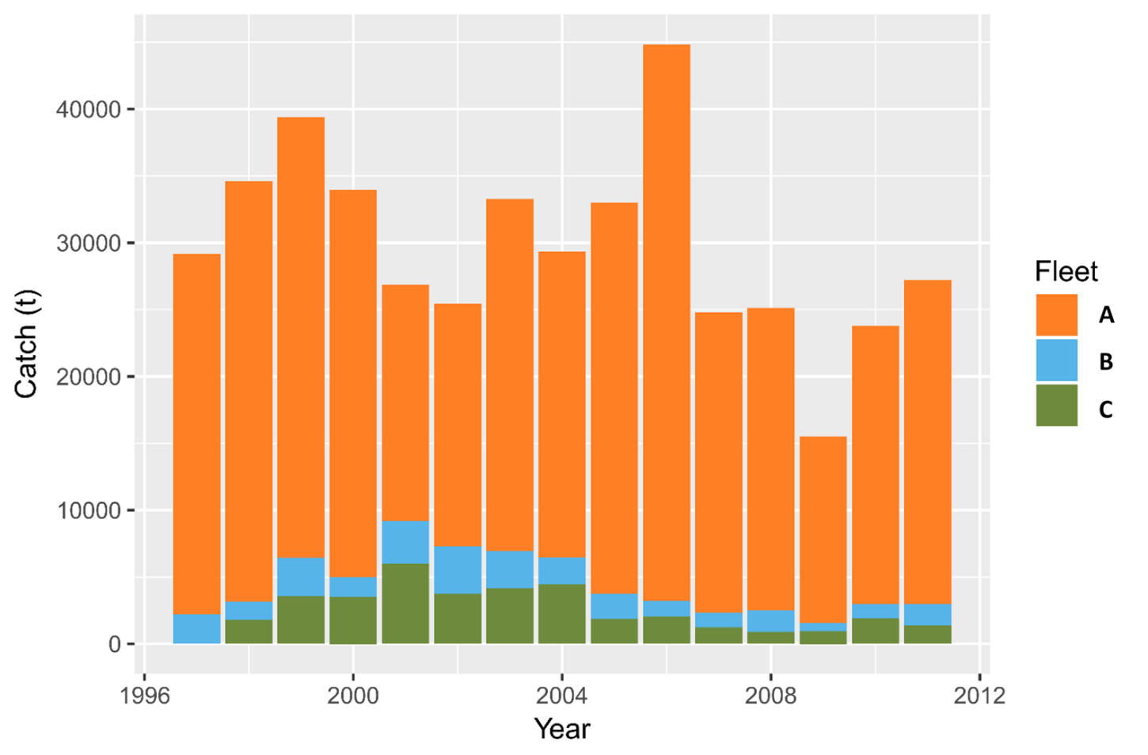

Figure 1. Catch by fleet in the last 15 years (1997-2011).

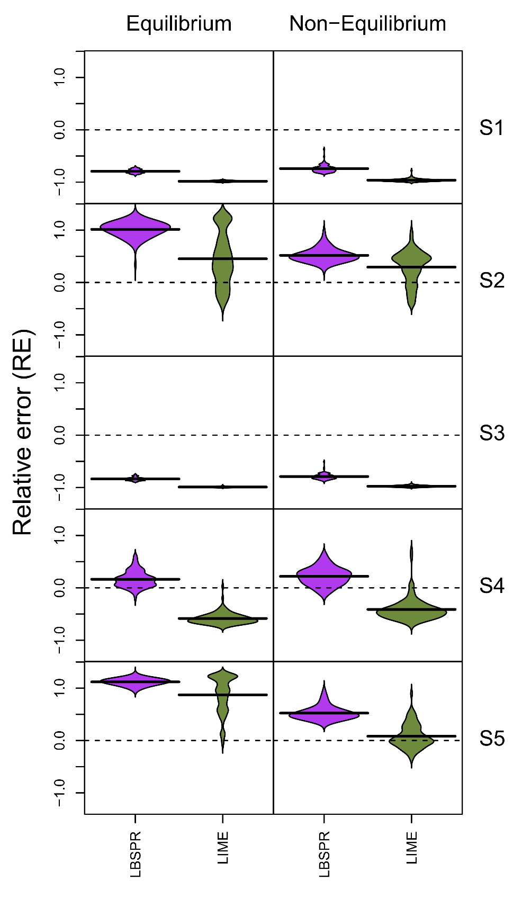 Figure 2. Relative error (RE) for the 5 Scenarios tested (S1 to S5) for LIME (green) and LBSPR (purple) compared with the OMs with (right column) and without (left column) recruitment deviations.

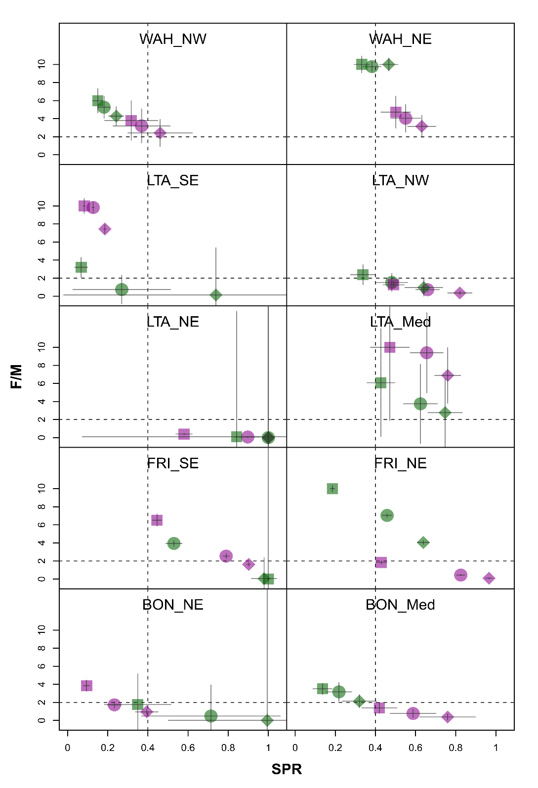

Figure 3. Proxy of stock status for priority small scombrid species.The vertical dashed line represents where SPR=40% and the horizontal one represents *F/M*=2. In green are the results from LIME and in purple for LBSPR for the three values of *M* considered. Circles are median *M*, squares are *M* at the 1st quartile and diamonds *M* at the 3rd quartile. The grey lines are the confidence intervals of the estimated SPR and *F/M*. LTA: little tunny; WAH: wahoo; BON: bonito; FRI: frigate tuna.

## Supplementary Information

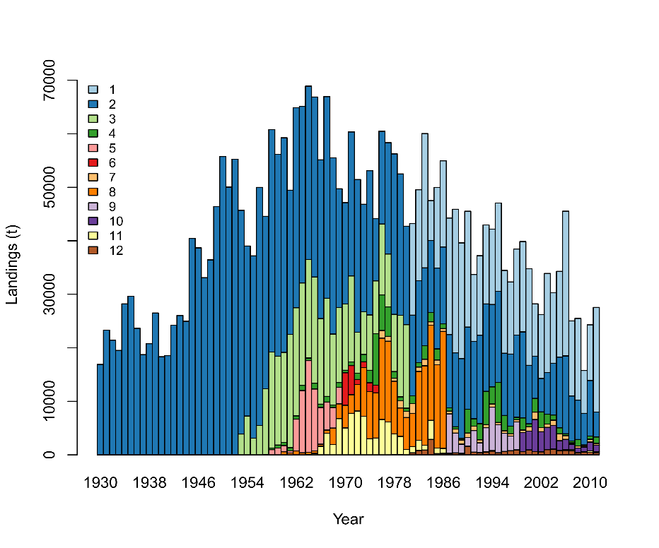

Figure S1. Catch of North Atlantic Albacore by fleet from 1930 to 2011 (ICCAT 2014).

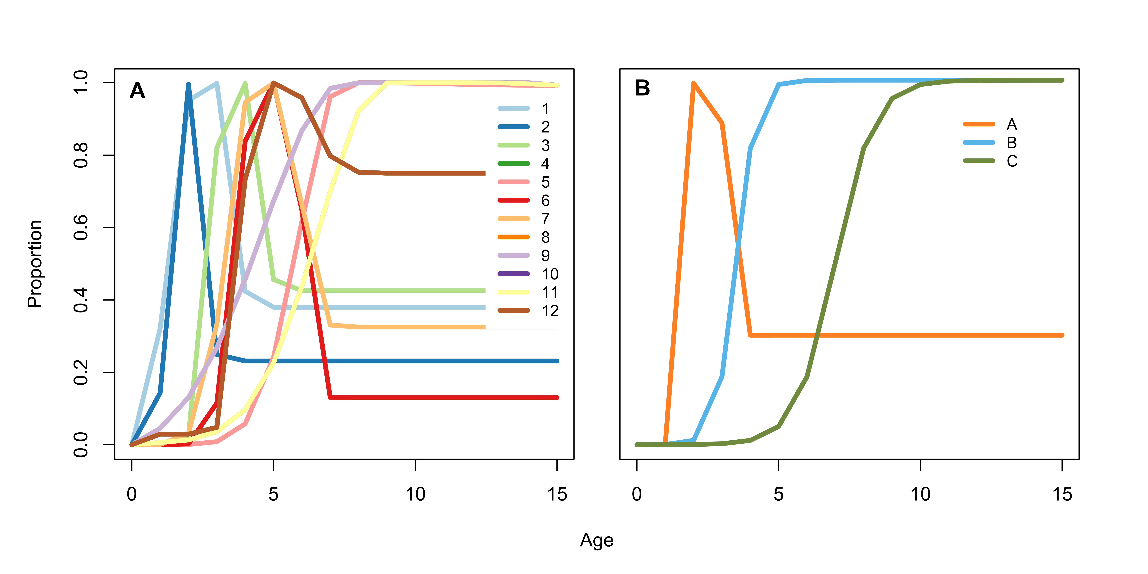

Figure S2. Selectivity curves. A: the 12 selectivity curves used in the 2013 North Atlantic Albacore assessment (Fleets 10 and 11, 8 and 9, and 4 and 12 have the same selectivity pattern). B: Combined selectivity curves to test under the different scenarios for the fleets that operated in the las 15 years (Fleets A to C).

Figure S3. ICCAT geographical definitions (Version: 2016.02) for small scombrids. Taken from: <http://iccat.es/Data/ICCAT_maps.pdf>.

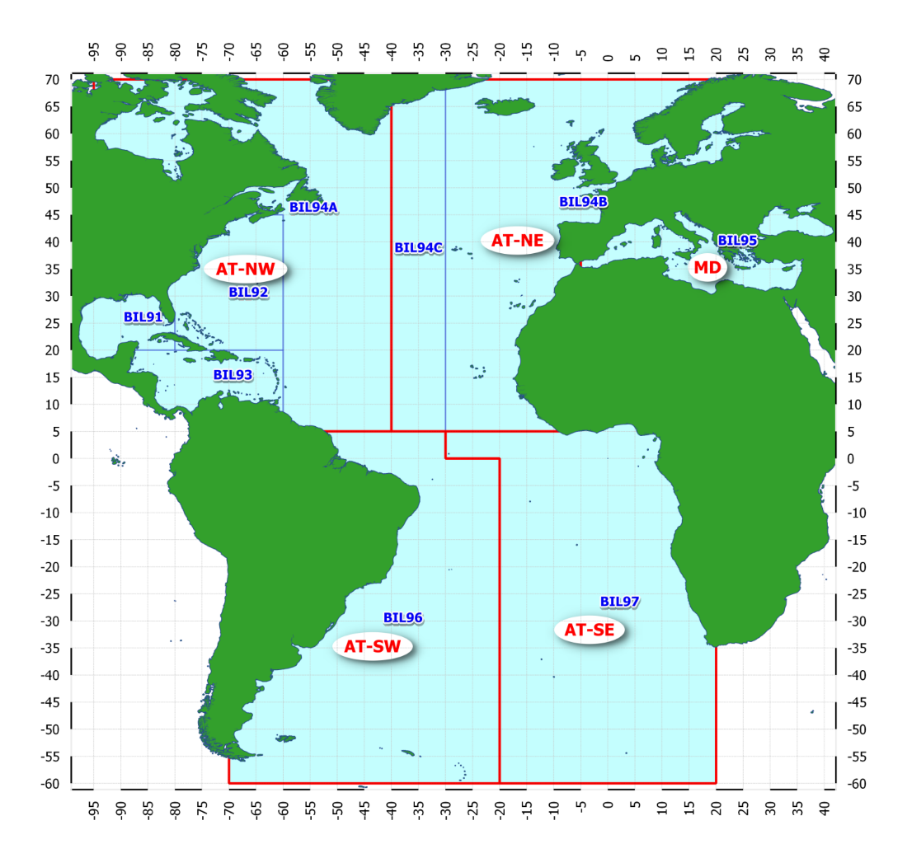

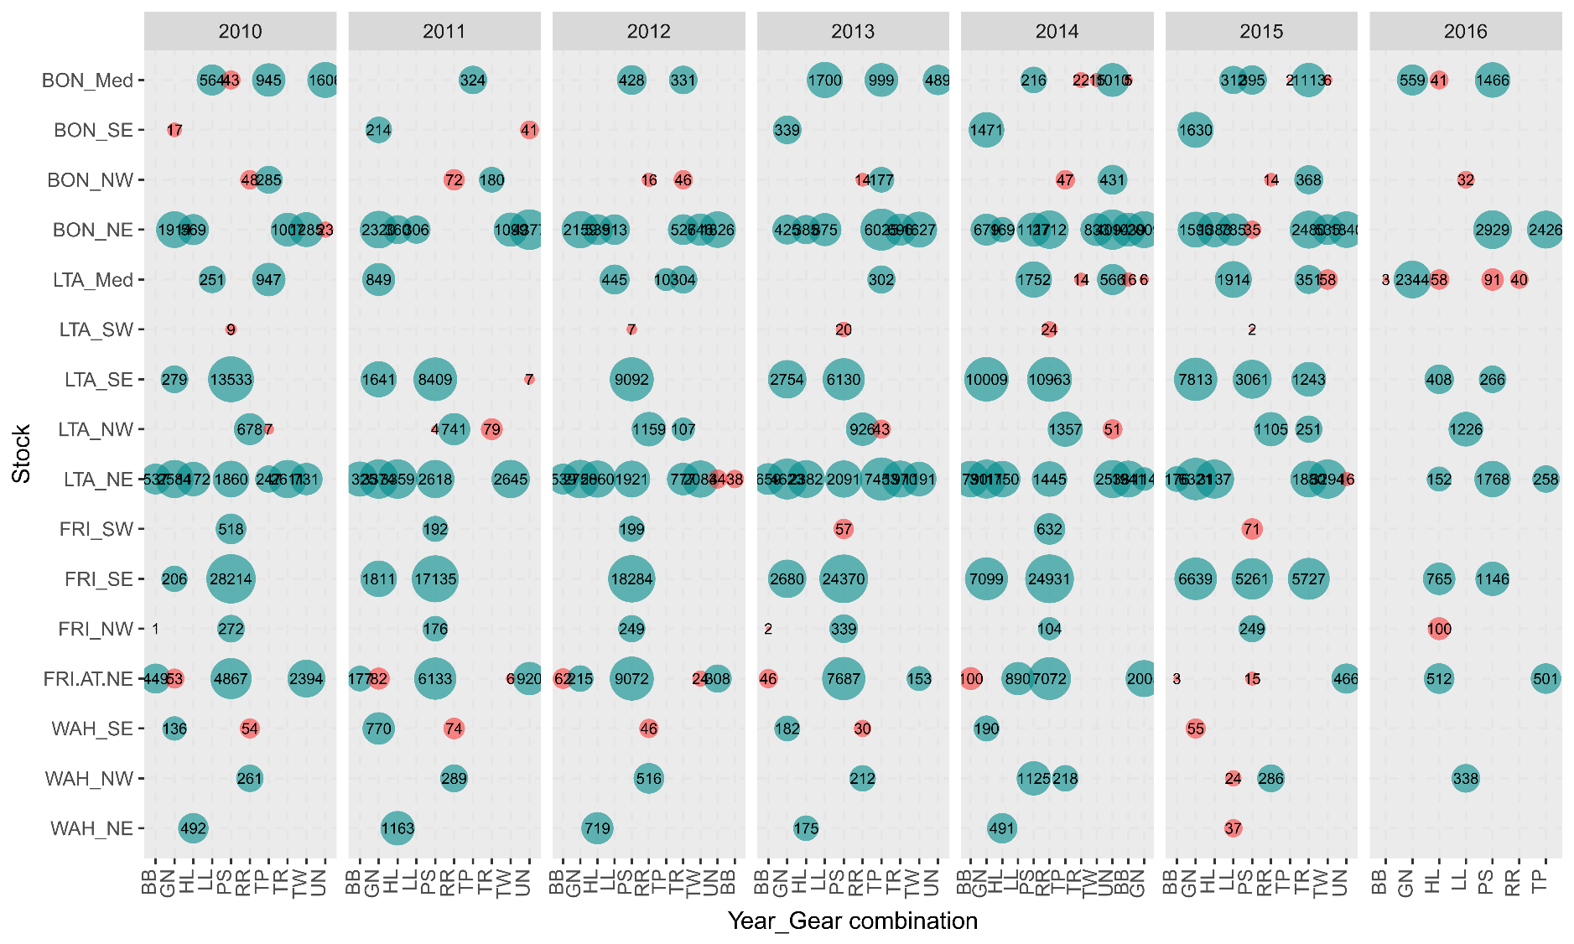

Figure S4. Number of fish measured by stock, year and gear from 2010 to 2016. The size of the bubbles is proportional to the logarithm of the number of fish measured and the number is inside the bubble. In red are those where the number of fish measured is less than 100. Gears: gillnets (GN); handline (HL); longline (LL); purse seine (PS); trap (TP); trolling (TR); trawl (TW); sport (SP); baitboat (BB); rod and reel (RR); haul seine (HS); trammel net (TN); unclassified (UN).

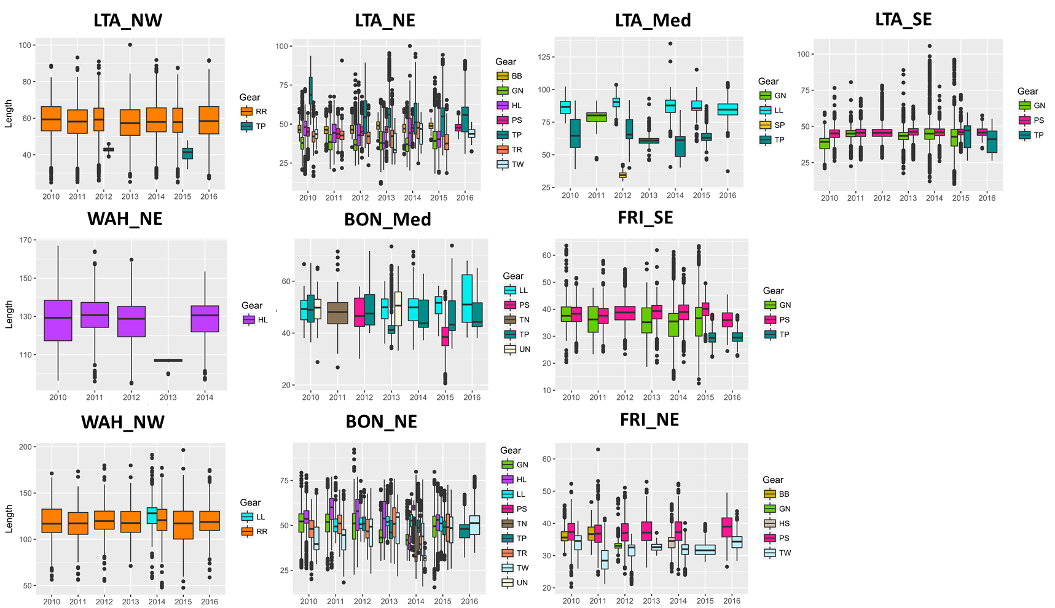

Figure S5. Length compostion data for the main stocks of small scombrids by gear in the Atlantic Ocean available in Task2sz databse of ICCAT. LTA: little tunny; WAH: wahoo; BON: bonito; FRI: frigate tuna. BB: bait boats; GN: gillnets; HL: hand lines; HS: haul seine; LL: longline; PS: purse seine; RR: rod and reel; SP: sport; TN: trammerl net; TP: traps; TR: trolling; TW: trawl; UN: unknown. NE: Northeast; SE: Southeast; NW: Northwest and Med: Mediterranean Sea.

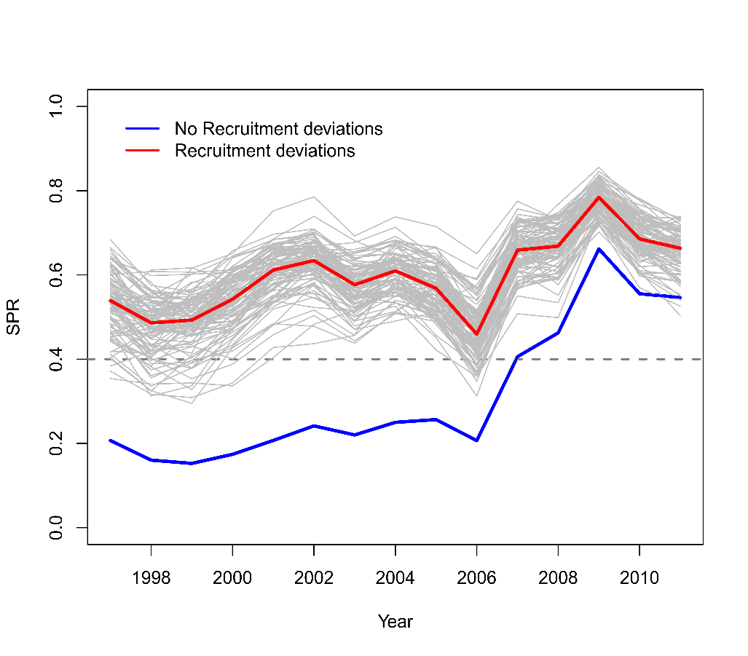

Figure S6. Time series of the true SPR for the 2 OM (with and without recruitment deviations). The grey lines are the SPR time series for each of the 100 runs with random recruitment deviations.

Table S1. North Atlantic Albacore age-length conversion matrix extracted from SS. Columns are the ages and rows are length bins.



Table S2. Life history information and references available for small scombrids in the Atlantic Ocean (ICCAT 2018).



**References from the Table S2:**

Baibbat, S., Malouli, I., Abid, N. and Benazzouz, B. (2016) Study of the reproduction of Atlantic bonito (*Sarda sarda*) in South Atlantic Ocean of Morocco. *Aquaculture, Aquarium, Conservation & Legislation - International Journal of the Bioflux Society* **9**, 954–964.

Cabrera, M.A., Defeo, O., Aguilar, F. and Martínez, J.D.D. (2005) La pesquería de bonito (*Euthynnus alletteratus*) del noreste del banco de Campeche, México. *Proceedings of the Gulf and Caribbean Fisheries Institute* **46**, 744–758.

Cayré, P., Amon Kothias, J.B., Diouf, T. and Stretta, J.M. (1993) Biology of tuna. In: *Resources, fishing and biology of the tropical tunas of the Eastern Central Atlantic*. *FAO Fisheries Technical Paper*. A. Fonteneau and J. Marcille (eds.) FAO, Rome, Italy, p 354.

Cayré, P. and Diouf, T. (1980) Croissance de la thonine (*Euthynnus alletteratus*) (Rafinesque, 1810) etablie a partir de coupes tranversales du premier rayon de la nageoire dorsale. *Document Scientifique - Centre de Recherches Océanographiques de Dakar - Thiaroye* **75**, 18.

Claro, R. (1994) *Características generales de la ictiofauna*, (Ecología de los peces marinos de Cuba). Instituto de Oceanología Academia de Ciencias de Cuba and Centro de Investigaciones de Quintana Roo, Qintana Roo, México.

Collette, B.B. and Nauen, C.E. (1983) FAO Species Catalogue. Vol. 2. scombrids of the world: an annotated and illustrated catalogue of tunas, mackerels, bonitos and related species known to date. FAO Fisheries Synopsis. No 125. Rome, FAO. pp. 137.

Diouf, T. (1980) Peche & biologie de trois Scombridae exploités au Sénégal: *Euthynnus alletteratus*, *Sarda sarda* et *Scomberomorus tritor*.

Frota, L.O., Costa, P.A.S. and Braga, A.C. (2004) Length-weight relationships of marine fishes from the central Brazilian coast. *Naga, WorldFish Center Quaterly* **27**, 20–26.

Grudtsev, M.E. and Korolevich, L.I. (1986) Studies of frigate tuna *Auxis thazard* (Lacepede) age and growth in the eastern part of the Equatorial Atlantic. *Collective Volume of Scientific Papers, ICCAT* **25**, 269–274.

Hajjej, G., Hattour, A., Hajjej, A., Cherif, M., Allaya, H., Jarboui, O. and Bouain, A. (2012) Age and growth of little tunny, Euthynnus alletteratus (Rafinesque, 1810), from the Tunisian Mediterranean coasts. *Cahiers de Biologie Marine* **53**, 113–122.

Hansen, J.E. (1987) Aspectos biológicos y pesqueros del bonito del Mar Argentino (Pisces, Scombridae, *Sarda sarda*). *Collective Volume of Scientific Papers, ICCAT* **26**, 441–442.

Hattour, A. (2000) Contribution a l’etude des poissons pelagiques des eaux Tunisiennes.

Hattour, A. (2009) Les thons mineurs tunisiens: étude biologiques et pêche. *Collective Volume of Scientific Papers, ICCAT* **64**, 2230–227.

Hogarth, W.T. (1976) Life history aspects of the wahoo *Acanthocybium solandri* (Cuvier and Valenciennes) from the coast of North Carolina.

IGFA (2011) World Record Game Fishes. International Game Fish Association, Dania Beach, Florida, USA.

Jenkins, K.L.M. and McBride, R.S. (2009) Reproductive biology of wahoo, *Acanthocybium solandri*, from the Atlantic coast of Florida and the Bahamas. *Marine and Freshwater Research* **60**, 893.

Kahraman, A.E., Göktürk, D., Yildiz, T. and Uzer, U. (2014) Age, growth, and reproductive biology ofAtlantic bonito (*Sarda sarda* Bloch, 1793) from the Turkish coasts of the Black Sea and the Sea of Marmara. *Turkish Journal of Zoology* **38**, 614–621.

McBride, R.S., Richardson, A.K. and Maki, K.L. (2008) Age, growth, and mortality of wahoo, *Acanthocybium solandri*, from the Atlantic coast of Florida and the Bahamas. *Marine and Freshwater Research* **59**, 799–807.

Ramírez-Arredondo, I. (1993) Aspectos reproductivos de la carachana pintada, *Euthynnus alletteratus* (Pisces:Scombridae) de los alrededores de la Isla de Picua, Estado Sucre, Venezuela. *Boletin del Instituto Oceanografico de Venezuela* **32**, 69–78.

Ramírez-Arredondo, I., Silva, J. and Marchán, F. (1996) Relación longitud peso y factor de condición en *Euthynnus alletteratu*s (Rafinesque 1810), (Pisces: Scombridae) de los alrededores de las Islas los Testigos, Venezuela. *Boletin del Instituto Oceanografico de Venezuela* **35**, 63–68.

Saber, S., Ortiz de Urbina, J., Lino, P.G., Gómez-Vives, M.J., Coelho, R., Lechuga, R. and Macias, D. (2017) Biological samples collection for growth and maturity studies EU Portugal and Spain: Northeastern Atlantic and Western Mediterranean. 41 pp. ICCAT, Madrid.

Santana, J.C., Delgado de Molina, A. and Ariz, J. (1993) Estimación de una ecuación talla-peso para *Acanthocybiun solandri* (Cuvier, 1832), capturado en la Isla de el Hierro (Islas Canarias). *Collective Volume of Scientific Papers, ICCAT* **40**, 401–405.

Sinovčić, G., Franičević, M., Zorica, B. and Cikes-Keč, V. (2004) Length-weight and length-length relationships for 10 pelagic fish species from the Adriatic Sea (Croatia). *Journal of Applied Ichthyology* **20**, 156–158.

Viana, D., Branco, I., Fernandes, C., Fischer, A., Carvalho, F., Travassos, P. and Hazin, F. (2013) Reproductive biology of the wahoo,  *Acanthocybium solandri* (Teleostei: Scombridae) in the Saint Peter and Saint Paul Archipelago, Brazil. *International Journal of Plant and Animal Sciences* **2**, 49–57.